**[REGex Software Services](https://www.linkedin.com/company/regexsoftware?trk=public_post_share-update_update-text)**

Java Full Stack Development Program

Registration I'd:  **IIPRSS1404**

Name: **Shanmukh Subhash Kumbhar**

College Name: Dr. D. Y. Patil School of Engineering And Technology, Pune.

Subject: Assignment - #Java Introduction

1. **Complete the installation of JDK.**

ANS – Done.

1. **Display the version of java on your pc?**

ANS –

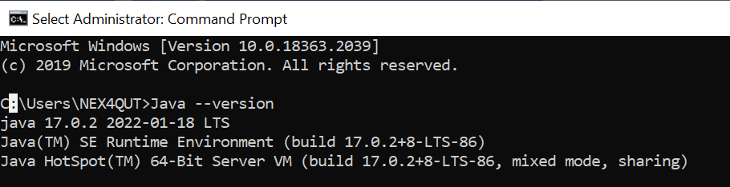

**3. Write a simple program to print the following**

**\*\*\*\*\*\*\*\*\*\*\*\*\*\*\*\*\*\*\***

**\*Learning java is fun”\***

**\*\*\*\*\*\*\*\*\*\*\*\*\*\*\*\*\*\*\***

ANS-

**public** **class** AssignmentFirst {

**public** **static** **void** main(String[] args) {

System.***out***.println("*******************");

System.***out***.println("*Learning java is fun”* ");

System.***out***.println("*******************");

}

}

